

SIMATS ENGINEERING
Saveetha Institute of Medical and Technical Sciences Chennai- 602105

Student Name: Adhavan Chandrasekar Reg. No.: 192521209
Course Code: CSA0509 Slot: A
Course Name: DBMS
Course Faculty: Dr.R.KESAVAN

Project Title: Smart Water Utility Consumption, Billing, and Complaint Management System
Module Photographs: (3 photographs –Module Photo, Individual student contribution module work in
the project and presentation image)
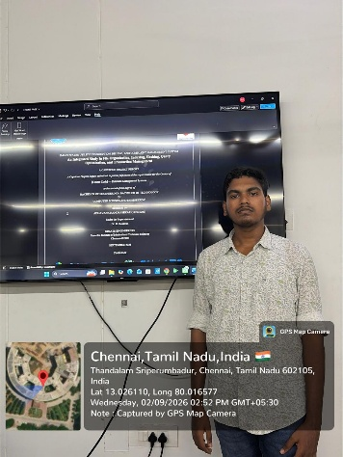
Project Description: (here you write what you did in this project (contribution) including Model
Description
Project Contribution :
Smart Water Utility Consumption, Billing, and Complaint Management is a database-based system designed to monitor water consumption, generate accurate bills, and manage customer complaints efficiently. It stores consumer, connection, meter, billing, and complaint details. The system improves transparency, reduces manual work, supports timely complaint resolution, and provides reliable reports for utility administrators.

Student Signature Guide Signature

